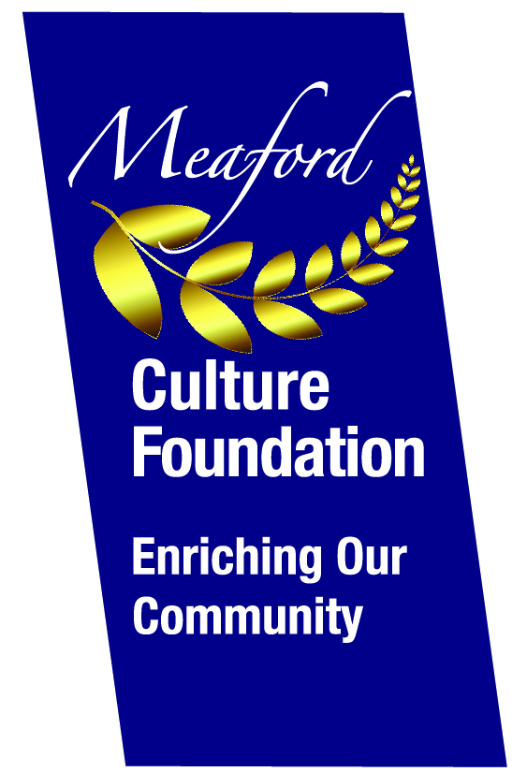
MEAFORD CULTURE FOUNDATION
VOLUNTEER INFORMATION 2021

MEAFORD CULTURE FOUNDATION
VOLUNTEER INFORMATION

MEAFORD CULTURE FOUNDATION
VOLUNTEER INFORMATION

MEAFORD CULTURE FOUNDATION
VOLUNTEER INFORMATION

What is The Meaford Culture Foundation (MCF)?
MCF is a fully independent, not-for profit, registered, charitable organization whose mission is to raise funds for arts and culture initiatives in the community and capital projects at Meaford Hall. It operates independently from both the Municipality and the Meaford Hall. All decisions are approved by a fully independent, volunteer Board of up to nine Directors.

Formerly known as the Meaford Hall & Culture Foundation, it was created in 2006 as a vehicle to raise the outstanding funds required for the completion of the Meaford Hall renovation. It was successful in achieving this goal and continued on to raise funds for major Hall improvements such as: the baby grand piano, the sprung stage, the elegant bar in the North Gallery and $145,000 towards the 2017 balcony renovation. The Foundation has committed to providing $65,000 towards the purchase of a new Hall projector and screen.
In 2018 the Foundation rebranded to Meaford Culture Foundation to reduce public confusion between our Foundation and Meaford Hall Arts and Cultural Centre.

Community Outreach Program
In 2008, the Foundation turned its attention to more involvement in the community with our Community Outreach initiative. Since then, it has annually allocated increasing amounts to community art, music, literacy, theatre, film and cultural awareness through funding and bursaries. We estimate that more than 1000 local children and teenagers benefit, either directly or indirectly, from this program each year. In 2020 we endeavored to supply school and art supplies to local children and teenagers studying at home during the pandemic.

Event and Fundraising Volunteer Requirements
MIFF (Meaford International Film Festival), our flagship cultural event, takes place at Meaford Hall on Labour Day weekend. The On-line Auction, our major fundraiser, occurs the last two weeks in November.
MIFF is a really fun event not only for patrons but also for the volunteers. It involves four days/evenings of films, dinners and ‘After Parties’ over Labour Day weekend. It requires 100+ volunteers to make this a successful event. There is a need for people to help with any of the following: brochure and poster distribution, decorating the party tent, preparing for the catered buffet meals, clearing tables, serving Party hors d’oeuvres and taking down decorations etc. the day after MIFF.
Online Auction volunteer requirements are mainly for: canvassing prospective donors, distributing posters and brochures and when the auction is over, helping to give out the auction items to the successful bidders

If you are interested in volunteering for any of these events, please contact Gail MacAlpine at gailmacalpine@gmail.com; 519-379-2707.

